Healthcare Planning Assistant Agent Report

  - Course Name: Agentic AI

Institution Name: Medicaps University – Datagami Skill Based Course

Student Name(s) & Enrolment Number(s):
Sr no | Student Name | Enrolment Number
1. | Ashlesha Verma | EN22CS301219
2. | Aryan Singh | EN22CS301215
3. | Avani Rawal | EN22CS301238
4. | Animesh Bokil | EN22CS301125
5. | Anshika Vyas | EN22CS301154

Group Name: 10-D2
Project Number: AAI-22
Industry Mentor Name: Aashruti Shah
University Mentor Name: Ajeet Singh Rajput
Academic Year: 2025-26

Problem Statement & Objectives
1. Problem Statement
Healthcare planning is a complex and multi-step process that requires accurate diagnosis, appropriate treatment recommendations, and verification of resource availability such as doctors and medicines. Traditional systems often provide generic advice or depend heavily on human experts, making the process time-consuming, costly, and sometimes inaccessible. Additionally, most existing solutions lack structured planning and intelligent decision-making capabilities.
There is a need for an automated system that can understand user-defined healthcare goals, break them into actionable tasks, and generate reliable, structured healthcare plans. This project aims to address these challenges by developing an Agentic AI-based system that simulates expert-level reasoning using a multi-agent architecture.

2. Project Objectives
- To develop an Agentic AI-based Healthcare Planning Assistant
- To implement a multi-agent architecture for intelligent task execution
- To design a Planner Agent for goal interpretation and task decomposition
- To integrate LLM-based reasoning using the Groq API (LLaMA 3 model)
- To generate structured and actionable healthcare plans

3. Scope of the Project
The project focuses on developing an Agentic AI-based Healthcare Planning Assistant that generates structured healthcare plans from user-defined goals. It incorporates multi-agent collaboration, task decomposition, and LLM-based reasoning.
The system operates using mock APIs and session-based data handling. It does not involve real patient data, real-time medical integration, or long-term data storage.

Proposed Solution
The proposed system is an Agentic AI-powered Healthcare Planning Assistant that performs the following functions:
- Accepts high-level healthcare goals from users

- Uses a Planner Agent to break goals into smaller, manageable tasks
- Assigns tasks to specialized agents such as Diagnosis, Treatment, and Resource Agents
- Utilizes tools (mock APIs) to validate medical and resource information
- Integrates with the Groq API (Meta LLaMA 3 model) for intelligent reasoning
- Generates a structured and comprehensive healthcare execution plan
This system simulates real-world healthcare decision-making using a modular and scalable multi-agent architecture.
- Key features
• Multi-agent collaboration system
• Autonomous task decomposition
• Planner Agent for intelligent decision-making
• Specialized agents (Diagnosis, Treatment, Resource)
• Tool-based validation (mock APIs)
• LLM-powered reasoning using Groq API
• Structured healthcare plan generation
• Modular and scalable architecture
• Fast inference using optimized LLM integration

- Overall Architecture / Workflow
- User Input Module
User provides a healthcare goal (e.g., “recover from fever”, “manage diabetes”).
- Planner Agent
Interprets the goal and decomposes it into smaller actionable tasks.
- Task Distribution Layer
Tasks are assigned to specialized agents:
- Diagnosis Agent
- Treatment Agent
- Resource Agent
- Agent Processing
Each agent performs its role:
- Diagnosis Agent analyzes symptoms
- Treatment Agent suggests care plan

- Resource Agent checks availability
- Tool Layer Interaction
Agents interact with tools:

- Patient Data Tool
- Medical Knowledge Tool
- Resource Checker Tool
- LLM Processing
Agents use Groq API (LLaMA 3 model) for reasoning and response generation.
- Output Generation
All responses are aggregated into a structured healthcare plan.

- Tools & Technologies Used
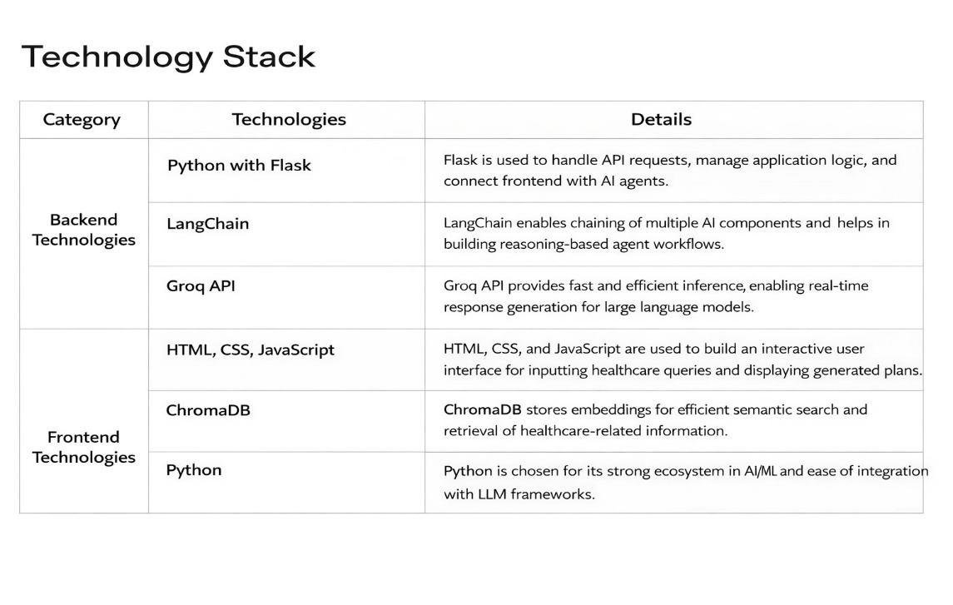

Results & Output
- Screenshots / outputs

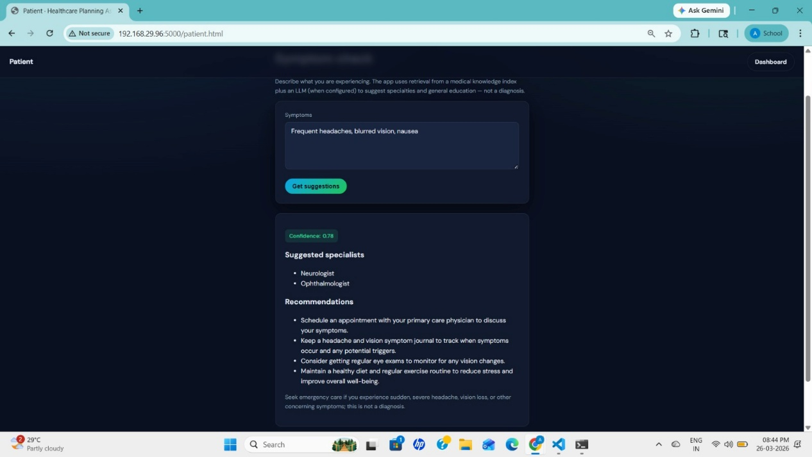

AI-Generated Outputs
- Structured Healthcare Plan
- Diagnosis Suggestions
- Treatment Recommendations
- Resource Availability Information

- Reports / dashboards / models

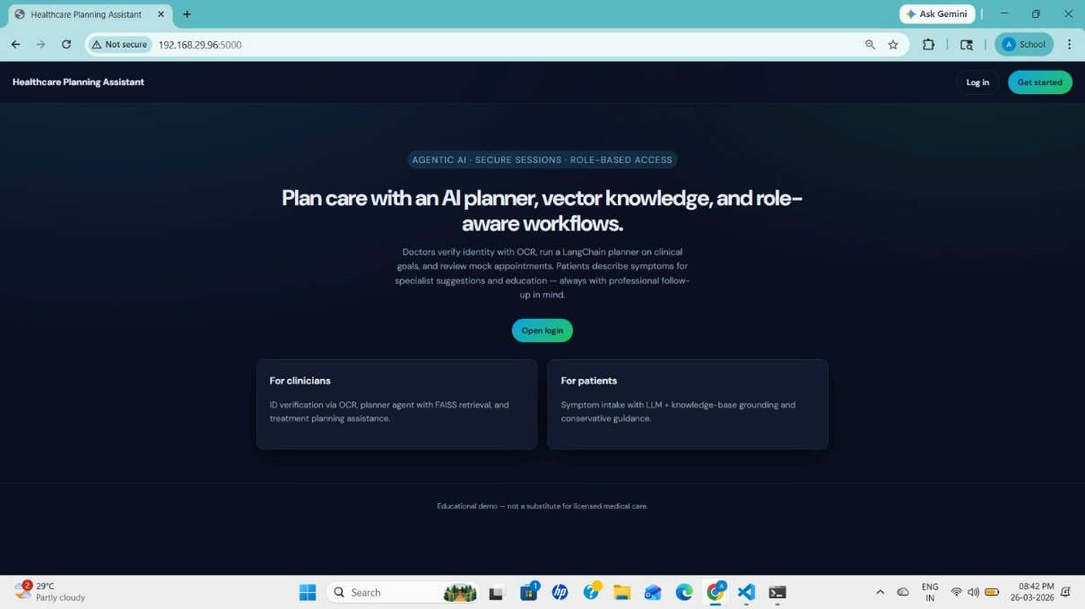

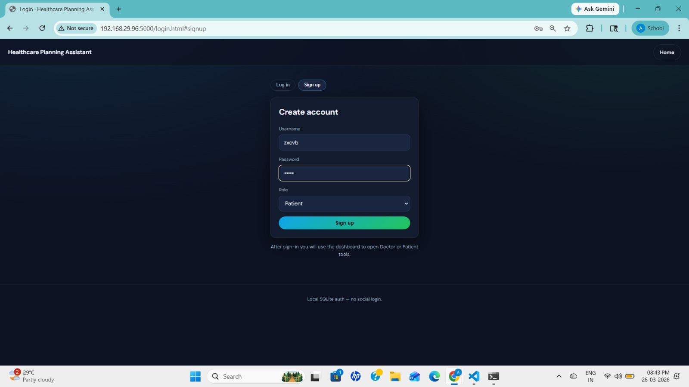

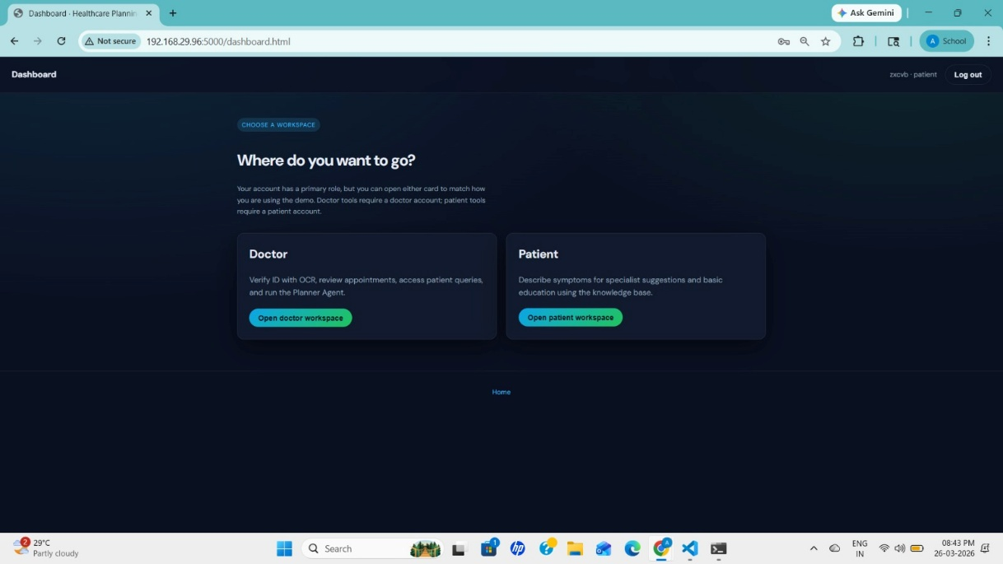

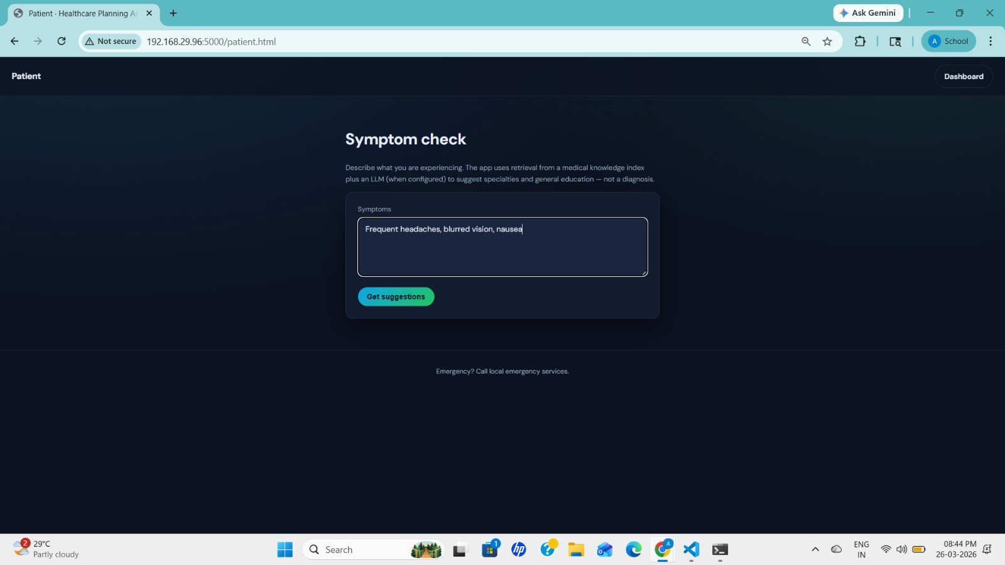

- Key outcomes
- Successfully implemented a multi-agent AI system
- Generated structured and actionable healthcare plans
- Achieved efficient task decomposition and execution
- Demonstrated LLM-based reasoning using Groq API
- Built a modular and scalable architecture
- Reduced complexity of healthcare planning process

Conclusion
The Healthcare Planning Assistant demonstrates the practical application of Agentic AI in solving complex healthcare planning problems. The system effectively combines multi-agent collaboration, task decomposition, and LLM-based reasoning to generate structured healthcare plans.
It highlights the importance of modular architecture and intelligent automation in modern AI systems. The integration of the Groq API with the Meta LLaMA 3 model ensures fast and efficient processing, making the system suitable for real-time applications.
This project provides valuable experience in Agentic AI design, LLM integration, and scalable system development.

Future Scope & Enhancements
- Integration with real healthcare databases and APIs
- Real-time doctor appointment and hospital systems
- Patient history and Electronic Health Record (EHR) integration

- Voice-based healthcare assistant
- Mobile and web application deployment
- Advanced AI models for diagnosis improvement
- Secure cloud deployment for large-scale usage
- Data privacy and encryption mechanisms

